# Exercise 2: E-commerce Platform Search Function

Code:

**Product.java** public class Product { private int productId; private String productName;

private String category;

public Product(int *productId*, String *productName*, String *category*) { this.productId = productId; this.productName = productName; this.category = category;

}

public int getProductId() {

return productId;

}

public String getProductName() {

return productName;

}

public String getCategory() { return category;

}

@Override public String toString() {

return "[" + productId + "] " + productName + " (" + category + ")";

}

}

**SearchTest.java:**

public class SearchTest {

public static void main(String[] *args*) { Product[] products = {

new Product(101, "Shoes", "Footwear"), new Product(102, "T-shirt", "Clothing"), new Product(103, "Laptop", "Electronics"), new Product(104, "Mobile", "Electronics"),

new Product(105, "Socks", "Footwear")

};

String searchTarget = "Laptop";

System.out.println(“Linear Search:");

Product result1 = SearchUtility.linearSearch(products, searchTarget); System.out.println(result1 != null ? result1 : "Product not found.");

System.out.println("Binary Search:");

Product result2 = SearchUtility.binarySearch(products, searchTarget);

System.out.println(result2 != null ? result2 : "Product not found.");

}

}

**SearchUtility.java** import java.util.*; public class SearchUtility {

public static Product linearSearch(Product[] *products*, String *name*) { for (Product product : products) {

if (product.getProductName().equalsIgnoreCase(name)) { return product;

}

}

return null;

}

public static Product binarySearch(Product[] *products*, String *name*) { Arrays.sort(products, Comparator.comparing(Product::getProductName)); int low = 0, high = products.length - 1;

while (low <= high) { int mid = (low + high) / 2;

int comparison = name.compareToIgnoreCase(products[mid].getProductName());

if (comparison == 0) { return products[mid]; } else if (comparison < 0) { high = mid - 1;

} else {

low = mid + 1;

}

}

return null;

}

}

**OUTPUT:**

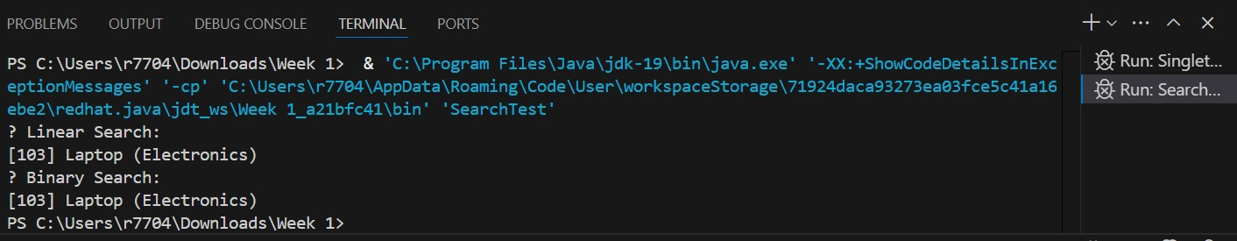

# Exercise 7: Financial Forecasting

Code:

**FinancialForecaster.java** public class FinancialForecaster {

public static double forecastRecursive(double *presentValue*, double *growthRate*, int *years*) { if (years == 0) return presentValue;

return (1 + growthRate) * forecastRecursive(presentValue, growthRate, years - 1);

}

// Optimized version using memoization

public static double forecastMemo(double *presentValue*, double *growthRate*, int *years*, Double[] *memo*) {

if (years == 0) return presentValue;

if (memo[years] != null) return memo[years];

memo[years] = (1 + growthRate) * forecastMemo(presentValue, growthRate, years - 1, memo); return memo[years];

}

}

**ForecastTest.java** public class ForecastTest {

public static void main(String[] *args*) { double presentValue = 10000.0;

double growthRate = 0.05; int years = 5;

double forecast = FinancialForecaster.forecastRecursive(presentValue, growthRate, years); System.out.println("Recursive Forecast after " + years + " years: ₹" + forecast);

Double[] memo = new Double[years + 1];

double forecastMemoized = FinancialForecaster.forecastMemo(presentValue, growthRate, years, memo);

System.out.println("Optimized Forecast with Memoization: ₹" + forecastMemoized);

}

}

**OUTPUT:**

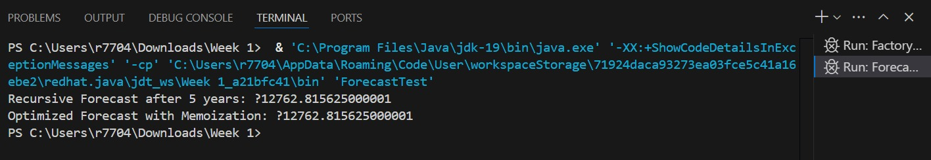

**Exercise 1: Implementing the Singleton Pattern**

Code:

# SingletonPattern.java

public class SingletonPattern {

public static void main(String[] args) {

Logger logger1 = Logger.getInstance();

logger1.display("Message from logger1");

Logger logger2 = Logger.getInstance();

logger2.display("Message from logger2");

if (logger1 == logger2) {

System.out.println("Same Logger instance used (Singleton verified).");

} else {

System.out.println("Different Logger instances (Singleton failed).");

}

}

}

# Logger.java

public class Logger { private static Logger logger=null; private Logger() {

}

public static Logger getInstance() { if(logger==null) {

logger=new Logger();

}

return logger;

}

public void display(String *str*) {

System.out.println(str);

}

}

**OUTPUT:**

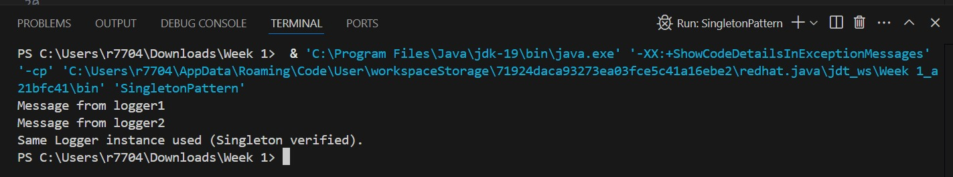

# Exercise 2: Implementing the Factory Method Pattern

Code:

**Documents Package:**

# Document.java

package documents;

public interface Document {

public void open();

}

# ExcelDocument.java

package documents;

public class ExcelDocument implements Document {

@Override public void open() {

System.out.println("Opening Excel document.");

}

}

# PdfDocument.java

package documents;

public class PdfDocument implements Document{

@Override public void open() {

System.out.println("Opening PDF document.");

}

}

# WordDocument.java

package documents;

public class WordDocument implements Document{

@Override public void open() {

System.out.println("Opening Word document.");

}

}

**Factories Package:**

# DocumentFactory.java

package factories;

import documents.Document;

public abstract class DocumentFactory {

public abstract Document createDocument();

}

# PdfDocumentFactory.java

package factories;

import documents.Document;

import documents.PdfDocument;

public class PdfDocumentFactory extends DocumentFactory{

@Override

public Document createDocument() {

return new PdfDocument();

}

}

# ExcelDocumentFactory.java package factories;

import documents.Document;

import documents.ExcelDocument;

public class ExcelDocumentFactory extends DocumentFactory{

@Override

public Document createDocument() {

return new ExcelDocument();

}

}

# WordDocumentFactory.java

package factories;

import documents.Document;

import documents.WordDocument;

public class WordDocumentFactory extends DocumentFactory{

@Override

public Document createDocument() {

return new WordDocument();

}

}

**Main Package:**

# FactoryMethodTest.java package main;

import documents.Document; import factories.DocumentFactory; import factories.ExcelDocumentFactory; import factories.PdfDocumentFactory;

import factories.WordDocumentFactory;

public class FactoryMethodTest {

public static void main(String[] *args*) {

DocumentFactory wordFactory = new WordDocumentFactory();

Document word = wordFactory.createDocument(); word.open();

DocumentFactory pdfFactory = new PdfDocumentFactory();

Document pdf = pdfFactory.createDocument(); pdf.open();

DocumentFactory excelFactory = new ExcelDocumentFactory();

Document excel = excelFactory.createDocument(); excel.open();

}

}

OUTPUT:

